A+ AWARENESS CERTIFICATION TEST

Please PRINT NEATLY all information below. Write your name in the exact manner that you would like to see it appear on your certificate. After filling in the information proceed with the test. After completing the test, you can mail it to our physical address or print, scan, and e-mail it back to Jermaine’s e-mail.

____________________________________________ ______________ ________________________________________________
First Name Middle Initial Last Name
_________ ______________________________________________ ______________________ _______ ____________________
Age Mailing Street Address City State Zip Code
____________________________________________________________ (_________) ______________ ________________
E-mail Address Phone # Receive Text?

Circle “True” or “False” as your answer to the question directly across from it.
T F 1. Awareness is one of the greatest tools of the Martial Artist for self-defense.
T F 2. You are at risk of an attack when you are with people in a well-lit crowded area.
T F 3. I should scan all areas for potential danger before entering.
T F 4. Personal Protection should be a priority for myself and loved ones.
T F 5. The brain can go into a state of shock during an attack.
T F 6. I will automatically fight back if attacked. I do not have to make the decision to fight.
T F 7. Criminals stick to the same areas. They never travel to commit crimes.
T F 8. If I believe I will never be attacked, positive thinking will keep attakers away from me.
T F 9. The person with good awareness can predict much danger before it occurs.
T F 10. All crimes are reported to the police and placed in statistics for us all to read.
T F 11. The best way to protect my loved ones is to teach them to protect themselves.
T F 12. Bullying never occurs on the social network.
T F 13. Pepper Spray is a better self-defense tool than a gun because it is more lethal.
T F 14. Criminals think of smart ways to attack people.
T F 15. The #1 weapon against the crime and criminals is tough talk and a baseball bat.
T F 16. It’s good to blast headphones in my ears while running outdoors so I can focus better.
T F 17. I need to beware of an attack from an animal while running outdoors.
T F 18. There are covert, hidden weapons that I can carry when running outdoors.
T F 19. Blowing my car horn is a good tactic to disrupt a potential attacker in a parking garage.
T F 20. I should put the address of the local police department under the “home” icon in my GPS
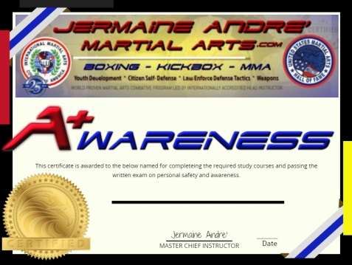
____E-Mail your COMPLETED TEST to KruAndreis@gmail.com and pay the $50 Testing fee by credit card over the phone, or

____ Mail your COMPLETED TEST & a Money Order or check for $55 to:
Jermaine Andre’ Martial Arts c/o Medici Mediaspace 2065 Walton Rd, Overland, MO 63114

www.JermaineAndreMartialArts.com * Text 636-578-9873 * kruandreis@gmail.com

